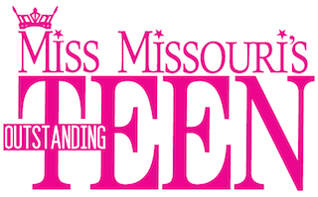

Miss Missouri’s Outstanding Teen Scholarship Pageant
2020 CLOTHING WAIVER

MISS _____________________________OUTSTANDING TEEN

NAME_____________________________________________

The undersigned agree that the Miss Missouri Scholarship Pageant Inc. may arrange to press and/or clean such garments as may be designated by me during the week of the Miss Missouri Pageant. We further agree to hold harmless and indemnify the Miss Missouri Scholarship Pageant, Inc. for any loss that may occur in regards to such garments.

GARMENTS WILLNOT BE CLEANED AND/OR PRESSED UNLESS WE HAVE THIS AGREEMENT.

Contestant Signature_____________________________________________

Parent/Guardian_____________________________________(Required if Contestant is under age 18 at time of signing

